**CHAPTER 1: INTRODUCTION**

Management of crime information has always been a tedious task for the government. Manual crime information management like writing in the files by the staff about detail information of criminal and the sufferer is very troublesome as well as inefficient. In this scenario, Crime Page Nepal is an integrated and distributed application which gives detail information about the criminal activities all over the Nepal in an organized way. It settles the problem to find out no. of crimes occurred within a particular region, types of crime prevalent within the region, region with the highest number of crime etc. Furthermore it will help the government as the decision support system for what strategies should be taken in consideration to reduce the number of crime.

Crime Page Nepal helps in generating crime reports of the different districts and also provides decision making bar-charts, pie-charts for the corresponding district and regional level as well as central level. This means that it is very straightforward to keep track of the detailed information about the criminals. It is a different approach from traditional system helping for data analysis in an efficient and fastest way. With the help of this system, it is possible to obtain all of the important and complete information about the criminals within a minute.

This system stores whole information about the crimes, criminals and sufferers. Beside this, the application gives the different privileges for different hierarchies of the system level users such as from district level up to central level.

The central system level user will organize and maintain the distributed crime reports for the fiscal crime report preparation. The application will facilitate the users to view the crime details on the google map with several hierarchies starting from the very five development regions.

## 1.1 Background

In Nepal, all the governmental institution related to crime investigation, analysis, decision making and others do not maintain the crime information scientifically and not fully computerized. Traditional file system is still popular on governmental institution due to the lack of capable manpower and due to the unwontedness of the employees to move with the new technologies. That is why this application focuses on the computerized and scientific storage of the crime reports which serve just not only the so called data retrieval but also for assisting the investigation, analysis, decision support, report generation and other critical operations for the crime related activities.

**1.2 Problem Definition:-**

After our visit to “Police Headquarter, Naxal” and “District Police Headquarter, Hanumandhoka” we got more information about the existing system regarding crime information management which helps us define the problem of the existing system.

Some of the problems identified are focused below:-

* There is no computerized system in most of the police headquarters.
* Direct uploading of files from different admins locally is not allowed.
* Difficulty in maintaining the database records.
* There is just a single authorized website to give information about the crimes to public but that also seems idle on giving full and recent information to public.
* Lack of good co-ordination between the nearest police stations.
* Lack of capable technology specific manpower to run even the simple existing computer system.

Since, manual crime information management is always incomplete and difficult to gain the complete information about criminal in the need, a small software can do the same with a wide variety of features then there will be no need to continue with manual crime information management system. Taking these into consideration, the necessity of the application like this would be a crucial one and one may think this as the initialization to cover the existing crime system to the next level.

## 1.3 Objective

The following listings are the objective of the application:

* To computerize the crime information world of Nepal, a beginning of an approach to the e-governance.
* To act as a full support system for the decision making bodies helping different crime controlling bodies to generate the crime report for presenting to the upper level.
* To facilitate the system users with the graphical presentations of the crime details with the location through the Google map.
* To provide a framework for the user to get all the crime details with supplying the location and crime nature and thus facilitating the system user comparing the criminal activities based upon the location, year and crime nature.
* To make easy and effective information gathering reducing the duplication of crime related documents and manages the whole information systematically. So that it will also be helpful to know easily if the same criminal involves in different types of crimes or not.

## 1.4 Scope and Limitations

**Scopes:**

The scope of crime page nepal is much wider than the existing manual system though it might not be fully efficient. It’s scope includes many areas such as police departments, crime investigation departments, researchers and general peoples.

Persons of different areas use this project for different purposes.

The crime investigation department uses this application to generate the report of the crime, and the causes of crimes which helps them to make the meaningful reports in the field of crime world.

This application helps to know the crime activities of Nepal location wise, category wise, age-group wise etc.

The person who needs the data of criminal activities for their research can also take help from this application. This application can take the whole criminal data of all over the Nepal in a managed and organized way hence making the crime investigation departments relieved from the ancient way of generating reports

**Limitations:**

None of the system is perfect and various factors affect the performance and working of the system. Following are some of the limitations of the project.

* Though it has many features from collecting crime data to report generation, but it itself does not have the capability to investigate the crime like the **“polygraph machine”** which is the recent technology for police department to investigate the crime by using **“Lie Detector”.**
* It is not an artificially intelligent system, the data fed into the system is what it take as a reference for generating reports.
* This application will not work fully if there is no internet facility in the machine where it is installed.

# CHAPTER 2: REQUIREMENT ANALYSIS

Requirement analysis in system engineering encompasses those tasks that go into determining the needs or conditions to meet for a new or altered product. It is an early stage in the more general activity of requirements engineering which encompasses all activities concerned with eliciting, analysing, documenting, validating and managing requirements of software.

Requirements analysis is critical to the success of a software project. The requirements should be documented, actionable, measurable, testable, traceable, related to identified business needs or opportunities, and defined to a level of detail sufficient for system design.

## 2.1 Study of Existing System

There are many existing crime record management system and related websites in use in the world these days. But in our country, the manual register based crime record management systems is prevalent mostly and a single authorized website of government is available to give crime information to the public which seems more idle in these days.

During the study of the existing system, we met some police officials related to crime investigation department and we tried to figure out if there are any software related to crime record management. According to them, there is only a software named **“I2 Intelligence System”** for crime investigation provided by foreign organization and there is no more than using the general purpose software like MS Excel for crime record management till. So, there is difficulty in using that crime intelligence software due to the lack of fast collection and retrieval of crime related data and information.

## 2.2 Data Collection Methods and Sources

This sub topic describes how the data was collected and the methods that were applied to analyse them.

Multiple methods were used to collect data for the purpose of developing the system. At first, informal conversation were conducted with some of the police officials. Since, from the conversation, we came to know that many real crime related data are critical to give for the public and so cannot be given to public. So we find easy to use fake data in most case to use in testing the system.

The data collections were made by simply extracting different types of crime related data from different websites and some fake data are also added. Criminal personal details like id, name, date of birth, address etc. Those things were considered while developing the system.

## 2.3 Software Requirement Specification

A software requirement specification for a software system is a complete description of the behaviour of a system to be developed and may include a set of use cases that describe interactions the user will have with the software. In addition it also contains non-functional requirements. Non-functional requirements impose constraints on the design or implementation (such as performance engineering requirements, quality standards, or design constraints).

### 2.3.1 Functional & Non-functional requirement

**Functional requirements:**

Functional requirements specifies specific behaviours and explains what the system is supposed to do by identifying the necessary task, action or activity that must be accomplished. Functional requirements analysis will be used as the top level functions for functional analysis. There will be mainly two types of user in the system:

System Level Users added by the Super Admin is basically responsible for entering the detail initial information like criminal’s personal details, crime location details and crime type details etc.

Super Admin is responsible for administering the system and perform the tasks like adding/deleting/modifying information and report generation.

**Interface Requirements**:

The user interface part is made in such a way that the data entry personnel or the administrator of the system will not be able to enter wrong data entry like field expecting numbers should be inputted with numbers only.

* + *Business Requirements:* The administrator should have administrative username and password to access the system and other are not allowed to access the system. Data must be entered before a request to be submitted. Clicking on any button does the respective task silently and notifies about the task success or failure information.
  + *Security Requirements:* Only administrators have full access to the system with administrative username and password. There can be more than one user made by the super admin. Super Admin can perform all necessary operations like adding user, assigning roles to users, allowing a set of permissions to the role, deleting user, modifying user, adding/removing other administrators, etc.

**Non-functional requirements:-**

Non-functional requirements are crucial software requirements that have to be specified early in the software development process. The dissatisfaction of non-functional requirements is one of the main reasons for the failure of software projects. Non-functional requirements are requirements that specify criteria that can be used to judge the operation of a system, rather than specific behaviours. Following are some of the non-functional requirements:

* *Operational requirement*: The system will be able to operate nicely provided that the system will not face power failure and internet disconnection. As this is developed in JAVA, it runs almost in all platforms so operating platform will not be an issue. No special hardware is required, as it can run in any personal computer with minimal hardware configurations.
* *Performance requirements:* The main part of the software which performs collection and management of crime reports is a java based web application with almost no performance interruption of the computer on which it runs.
* *Maintainability requirements*: If system fails to work, re running the software will pick up where it should have to. So from this point of view, maintaining the software is so easy. There is no need of expert personnel for maintaining the software in case of simple failure.

## 2.4 Feasibility Analysis

The feasibility study is an evaluation and analysis of the potential of a proposed project which is based on extensive investigation and research to support the process of decision making. Feasibility studies are crucial during the early development of any project and form a vital component in the system development process. It will also sum up the strengths, weaknesses and validity of assumptions as well as assessing the financial and non-financial costs.

A feasibility study assesses the operational, technical and economic merits of the proposed project. From the system analyst perspective, the feasibility analysis is the primary tool for recommending whether to proceed to the next phase or to discontinue the project.

### 2.4.1 Economic Feasibility

For any system if the expected benefits equal or exceed the expected costs, the system can be judged to be economically feasible. In economic feasibility, cost benefit analysis is done in which expected costs and benefits are evaluated. Economic analysis is used for evaluating the effectiveness of the proposed system.

This system is web based application and there is no need for renew of the domain name, web space. There is no chance of document loss. To run this application, there is just the need of one administrative user, one desktop computer, access of internet service for each location where this application will run. So, taking into consideration all these factors it is easily affordable. So, this system is economically feasible.

### 2.4.2 Technical Feasibility

In technical feasibility the following issues are taken into consideration.

* Whether the required technology is available or not.
* Whether the required resources are available.
* Availability of manpower.

At first, this system is presumed to be implemented in police departments including crime investigation departments of only three districts due to technical factors. We will implement it in Kathmandu, Lalitpur and Bhaktapur where a simple PC and the internet facility can be easily available. Once these infrastructures are met, this system can be easily implemented. No special or dedicated hardware is required. Any system with minimum configuration can run the software without any bugs.

Regarding the manpower, though separate manpower is not required because staff of the police department can operate this system easily after some software trainings and guidance. So this system is technically feasible.

### 2.4.3 Operational Feasibility

A system that has operational feasibility is one that will be used effectively after it has been developed. If users or administrator have difficulty with a new system, it will not produce the expected benefits. Operational feasibility depends on several issues. It is made with the assumption that the organization is well equipped with at least one PC.

If the organization meets the above criteria, there are no any other issues that affect it from working it smoothly, so this system is operationally feasible.

## 2.5 System Planning

The planning of this system started from the beginning of 7th semester. We started with gathering all the basic requirements of the system. After developing an algorithm of how the software would function, its database schemas were designed. Crime Page Nepal is a web based application. We planned to use **JAVA EE(Spring)** with **JSF(Java Server Faces)** and **PRIMEFACES(UI Framework)** as front end programming language and **Postgresql** as back end for database. **NETBEANS IDE 7.2** was planned to use before but later with the release of **NETBEANS IDE 7.4**, we use version **7.4** with Apache Tomcat6/7 and glassfish server as server during development of system.

### 2.5.1 Software Development Model

There are many software development models. Among them we have followed mainly two types of model in the development of the software as it consists of independent parts or modules. Each model were developed using waterfall model and their integration was done using component based model.

**Waterfall Model:**

Since our software development process is a sequential design process in which progress is seen as flowing steadily downwards like a waterfall through the phases of requirements, design, construction, testing, implementation and maintenance. We use waterfall model as a software development model.

Requirements

Design

Implementation

Integration

Maintenance

Fig 2.1: Waterfall Model

1. **Requirement Definition**

In this phase, a complete behaviour of the system to be developed was analysed in detail. The system was required to record the information like criminal’s personal details, sufferers’ personal details, crime types and location etc. The system was required to have a full administration part which would allow the administrator to perform basic administrative tasks like adding, removing or modifying information about crimes, criminals and sufferers; adding, removing, modifying users and generating complete reports.

1. **System design**

In this phase, the algorithm and basic working mechanism was designed. Algorithm was to be designed in such a way that same records of criminals should not be repeated. A major attention has been paid in keeping record about criminal’s personal details, crime details and sufferer details. Designing was done considering the Admin panel.

1. **Implementation**

After the overall algorithms were developed and basic idea of how the system should function was developed in detail, the implementation or coding was done. Application was developed using JAVA language. Few modules were made, and was tried to make as much independent as possible.

1. **Integration**

**Since the system consists of some modules, the integration part was crucial and important. Sub modules within Admin panel were integrated which would be more than sufficient. Every testing was performed in Admin Panel because it is the heart of the overall system and without report generation the project would be useless. Though testing was solely done using few debugging techniques.**

1. **Operation**

The project is mainly targeted for police departments where staff using this application is equipped with personal computer; the operation goes smooth once the requirement of the user with the computer along with the internet connection is possible. Admin is the sole responsible person for inserting, updating, deleting the other user of the system and other information about the criminals and sufferers and generating complete report will be more than sufficient in operation unless unexpected behaviour may happen. Maintenance is very easy part. If something goes wrong, re-adding the software to the start-up will fix the problem. Records could be easily stored in database.

### 2.5.2 Resources Requirement

Resource requirement for this software includes basically the following things:

* A normal PC for admin or user.
* Internet connectivity.
* Manpower responsible for administering the system.

The cost of development is not considered as this is developed for the partial fulfilment of the requirement of Bsc.CSIT.

# CHAPTER 3. DESIGN

Software design is a process of problem solving and planning for a [software](http://en.wikipedia.org/wiki/Software) solution. After the purpose and specifications are determined, a plan for a solution was designed and developed. It includes low-level component/modules and [algorithm](http://en.wikipedia.org/wiki/Algorithm) implementation issues as well as the [architectural](http://en.wikipedia.org/wiki/Software_architecture) view.

**3.1 Flowchart:**

Flowcharts are a methodology used to analyse, improve, document and manage a program. They are commonly used in developing business plans, designing algorithms and determining troubleshooting steps. 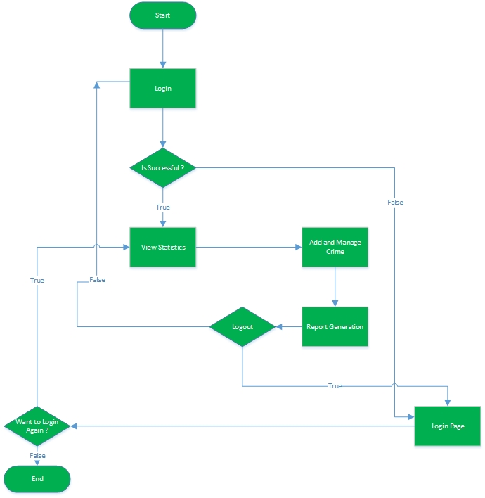

Fig 3.1: Flow Chart

The flowchart is a means of visually presenting the flow of data through an information processing system, the operations performed within the system the sequence in which they are performed.

The above figure is a high-level flowchart showing the major process of project flow. The start and end of the sequence are denoted by oval symbol. The arrows indicates the flow of sequence and progress from one step to another. The rectangular symbol denotes the step or a process activity. The diamond shaped icon is used to make decisions which affect how the process will proceed. When the outcome of the decision is TRUE, the user would follow one set of steps, and if the outcome is FALSE, the user would do another set of steps.

After the user name and password is inputted in the login section, if the input given is wrong, then the user is taken back to the login page. If it is successful then the user can enter to the application and can do what he is granted such as viewing statistics of crime information, add and manage crime and generating the report too. After finishing his task, he can easily logged out and he will be taken to the login page again.

**3.2 ER Diagram:**

ER diagram is a data modeling technique that creates a graphical representation of the entities, and the relationships between entities, within an information system.

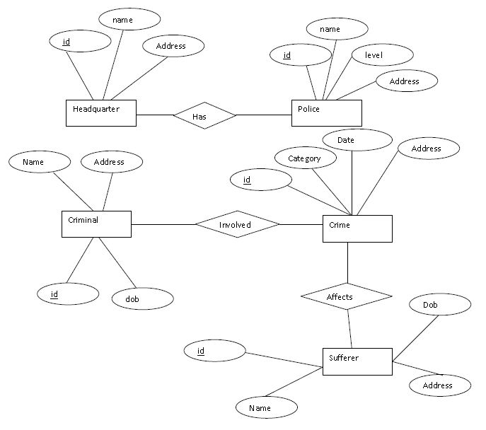

Fig 3.2: ER Diagram

First of all, all entities were identified and all significant interaction between them were determined. The entities are denoted by rectangular boxes, attributes by oval shaped icon and the relationship between the entities are shown by diamond shapes icon. There are different types of entities such as headquarter, police, criminal, crime and sufferer with their respective attributes.

Headquarter has id, name and address as its attributes. Police has id, name, level and address. The two entities Criminal and sufferer have id, name, date of birth and address. The entity crime have id, category, date and address. The relationship is shown in such a way that headquarter has police and the criminals involved in criminal activity which affects the public people commonly called sufferer.

## 3.3 Use-Case Diagram:

Use case is a list of steps, typically defining interactions between a role and a system, to achieve a goal. The actor can be a human or an external system.

Use-case diagrams graphically depict system behaviour (use cases). These diagrams present a high level view of how the system is used as viewed from an outsider’s (actor’s) perspective. A use case defines the interactions between external actors and the system under consideration to accomplish a goal. A use-case diagram may depict all or some of the use cases of a system.

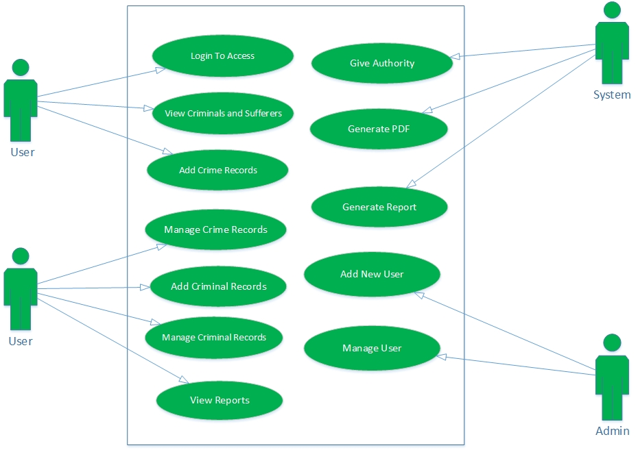

Fig 3.3: Use-Case Diagram

The above diagram depicts the use-case of the project where the users, admin and system are considered as actors. The named oval icons inside the box are the high-level functions that capture the various uses the actors have for the system. The line is drawn between the actor and function to indicate that an actor will make use of a particular function of the system.

**3.4 Context Diagram**

A context diagram pictures the system at the centre, with no details of its interior structure, surrounded by all its interacting systems, environment and activities. The objective of a system context diagram is to focus attention on external factors and events that should be considered in developing a complete set of system requirements and constraints. Context diagrams are used to display how a system inter-operates at a very high level or how system operates and interacts logically.

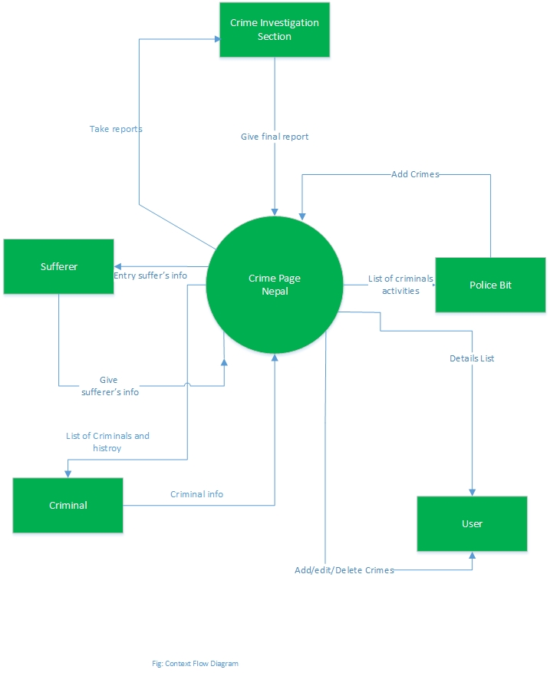

Fig. 3.4: Context Diagram

In the above diagram, the system crime page Nepal is the process and external entities are the crime investigation section, criminal, sufferers, police bit and user respectively.

First of all, sufferer go to the police bit and request for crime entry in that bit. The detail of crime can be entered through the system. The role of user is to take criminal details and add/delete/edit crime into the system. The system lists the criminal information and it can give the list of criminal history whenever necessary. Finally, crime investigation section takes initial data, crime nature and all activities of the crime from the system and generates final report.

**3.5 Data Flow Diagram**

A Data Flow Diagram (DFD) is a graphical representation of the flow of data through an information system modelling its process aspects. Data flow diagram can be used to provide the end user with a physical idea of where the data they input ultimately has an effect upon the structure of the whole system. Data Flow Diagrams can be used in both analysis and design phase of SDLC.

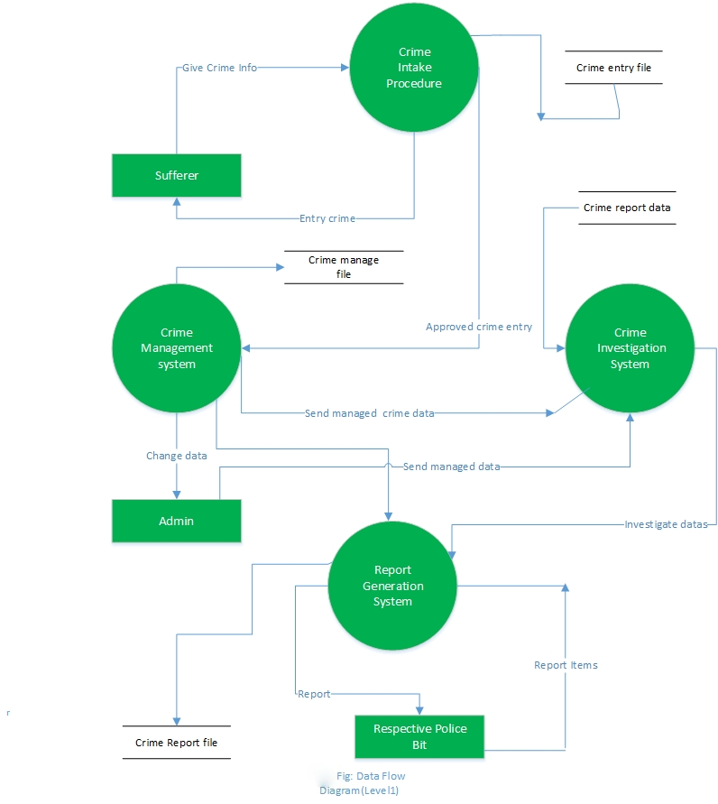

Fig 3.5: Data Flow Diagram (level 1)

In the above figure, there are total four processes which are represented by circles. External entities sufferer, admin and police bit are represented by rectangle. The open ended boxes represents the data stores and the arrows represents data flows.

The **crime intake procedure** (process 1) first takes the information from sufferers about criminal and sufferer and initial data entry job is done through this process. Besides, there is a crime entry file as the form of crime data. After approval, the crime entry procedure send these information in **crime management section** (process 2). In this process, all crime entry data are managed by admin and crime managed file is beside there.

Admin then send the managed data to **crime investigation system**(process 3) where these data are investigated through different sections and send to **report generation system**(process 4) to generate report.

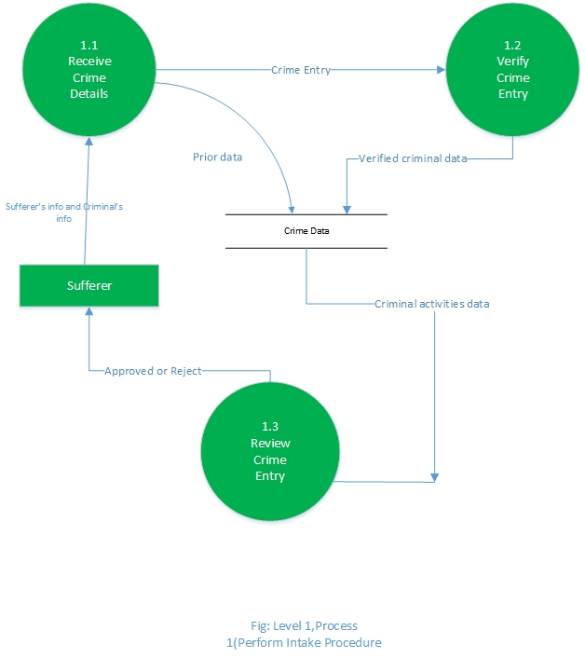

Fig 3.6: Data Flow Diagram (Level 1 process first)

Above figure shows the process from receiving the crime details from sufferer upto the approval or rejection of the information. First of all, after receiving crime details (which is process 1.1) from the sufferer in crime intake procedure, the verification process is done in process 1.2 and the verified data along with the prior data are then sent to data store. Finally, these data are reviewed again and send message to sufferer about either the data given by sufferer is approved or rejected.

## 3.6 Modules Description

The system consists of mainly two kind of users namely: the Super Admin and the System Level Users added by the Super Admin. Both of the users view the same user interfaces. The menus and the panels are displayed according to the permissions added to the system level users added by the super admin.

**Module One: With Super Admin Privileges**

The Super admin can add any of the system level user to maintain within the system. None of the users in the system except the Super Admin can view the user add panel and the user management panel. Besides these the super admin can add criminals, sufferers and the crime in the system as well as manage them. Furthermore, the super admin can delete and edit any of the data added by the system users in the system. The super admin can also generate reports and view the crime charts in the system as well.

**Module Two: With the system level Privileges**

This section looks similar to that for the admin but the difference is in the viewing menus and panels they are authorized to be viewed by the super admin. According to the access permissions defined by the roles added by the super admin this module is dynamically generated.

This module can thus give access to the report generation and viewing of the crime statistics with the bar charts and pie charts, if the super admin gives the permissions to the user currently logged in.

## 3.7 Interface Design (Form and Report)

User interface is very important part of almost any software because it allows user interaction. Super admin has central control to information, crimes, criminals, sufferers, role and user management, providing user with a nice interface to interact with the system. Following are some of the snapshots of the user interface.

Sample Screenshots:

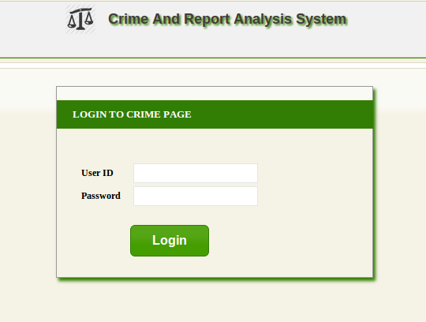

Fig 3.7: Login Page

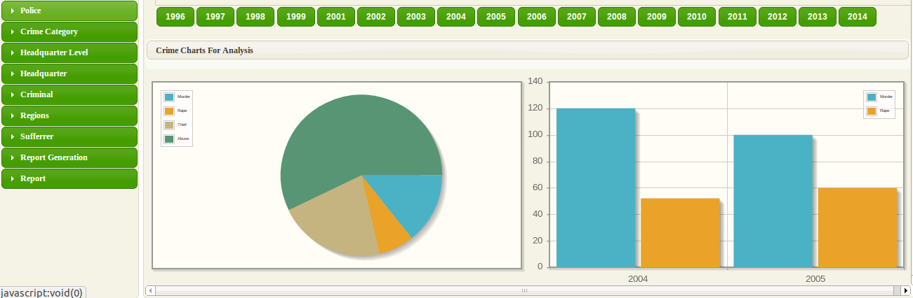

Fig 3.8: Home Page after successful login

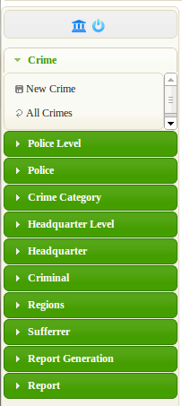

Fig 3.9: Sidebar

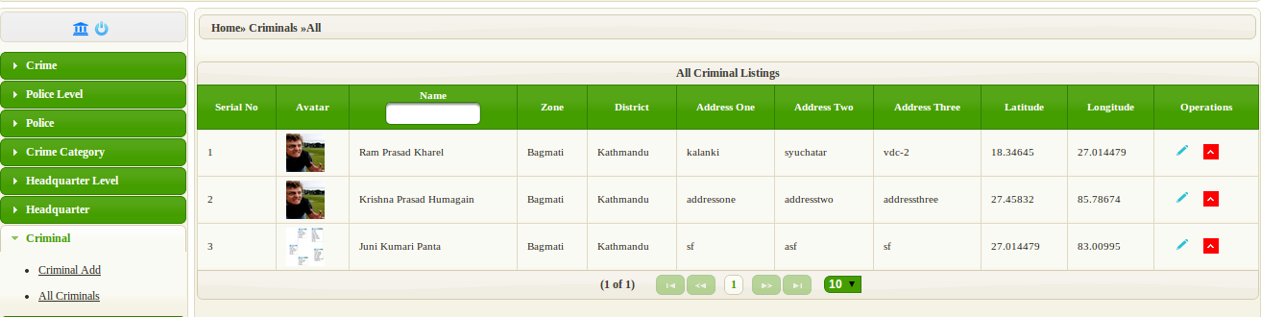

Fig 3.10: All Criminals

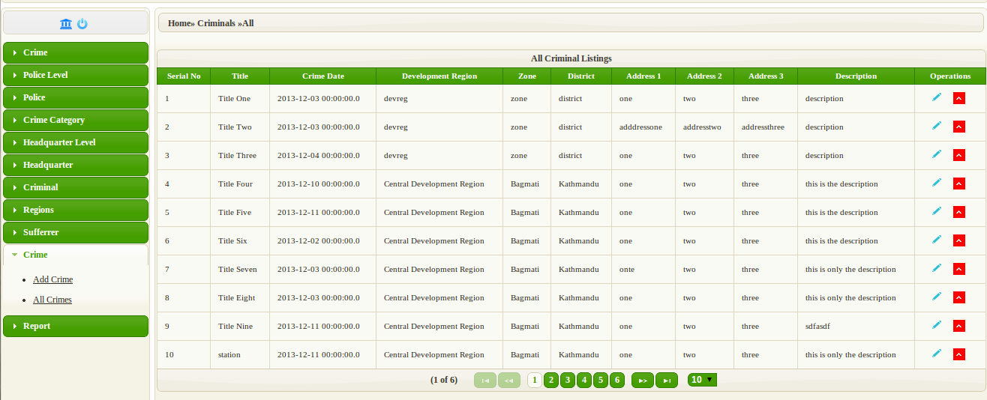

Fig 3.11: All Crimes

Crime Add Section: screenshots

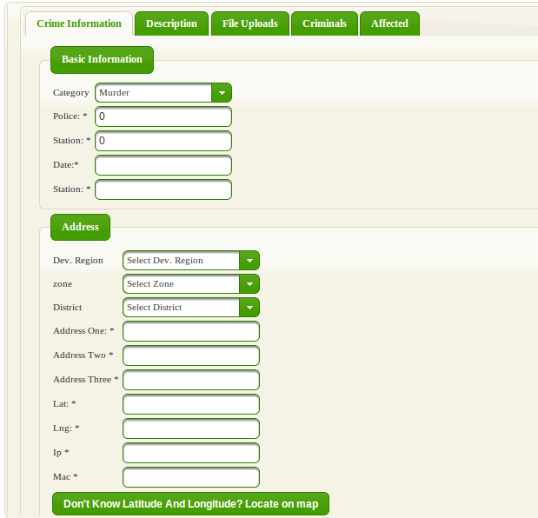

Fig 3.12: General Crime Info

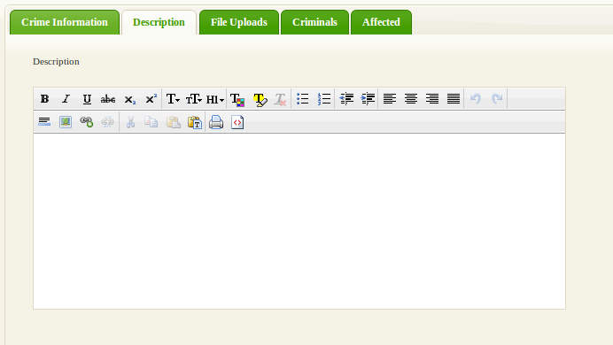

Fig 3.13: Crime Description Input Text Area

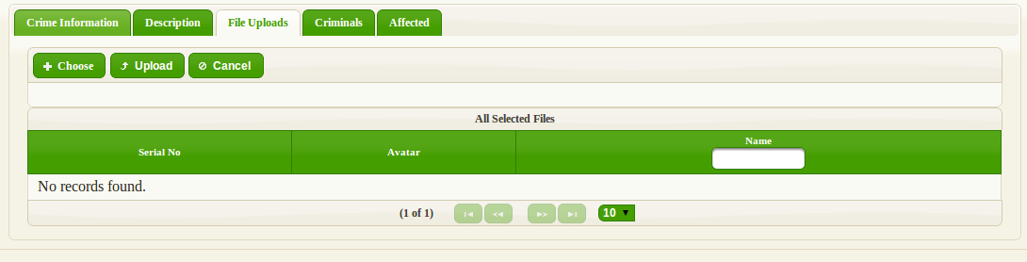

Fig 3.14: Crime File uploads

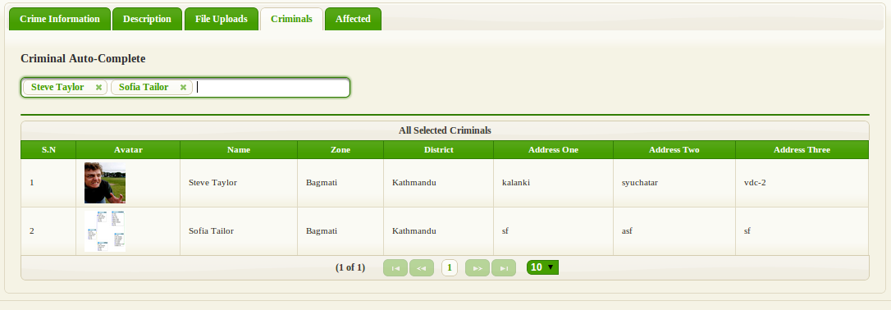

Fig 3.15: Crime Criminal Add

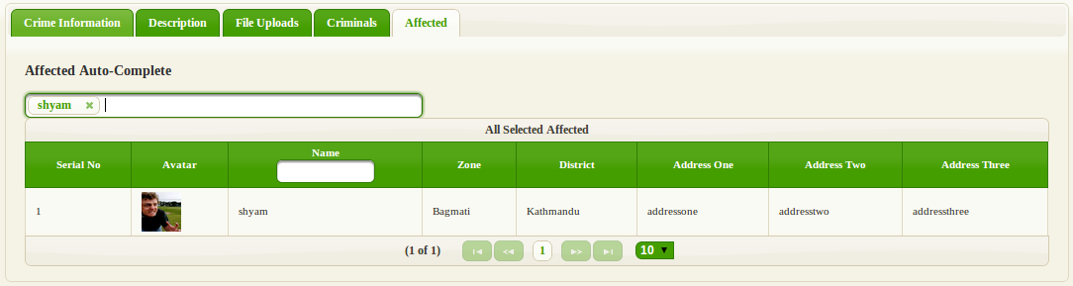

Fig 3.16: Crime Sufferer Add

**CHAPTER 4: DEVELOPMENT AND TESTING**

Development and testing are two implementation part of the software development task. Development consists of coding and testing includes performing various test to make the software fail. Testing and coding goes almost side by side in software development.

## 4.1 Development Tools

Various coding tools were used during the development of the system.

* NETBEANS IDE 7.4 as a platform.
* JAVA EE (Spring Framework) as a programming platform.
* JSF and PRIMEFACES as UI frameworks.
* POSTGRESQL 9.3.1 as a database server.
* PgadminIII for the database client.
* Google map JavaScript API

**4.2** **TESTING**

While developing the application testing was extensively carried out to check if the system is error prone or not. The main testing task was carried out using Netbeans IDE Debugging Tools. Unit testing using the JUnit was carried out during the development time. Following are few testing that were performed to name a few:

**Test Coverage:**

**Log In:**

Input: Correct username and incorrect password

Expected output: Log In

Actual output: Incorrect username or password

Input: Incorrect username and correct password

Expected output: Log In

Actual output: Incorrect username or password

Input: Incorrect username and incorrect password

Expected output: Log In

Actual output: Incorrect username or password

Input: Correct username and correct password

Expected output: Log In

Actual output: Log In

# 

# CHAPTER 5: SUPPORT

Support is very important after deployment or during deployment. As the users or clients are not always expert to use the software; and they may face many problems from the start to end of the use of the system. Following are various parts where the support is quite essential.

## 5.1 Implementation Plan

After the system is successfully developed, the system should be deployed or implemented. The implementation will be carried out by on spot installation of the system maintaining the favourable environment for the system to successfully perform the operation. Respective person will be explained in detail about the use of the system and its working procedure. For this, he/she will be given a short training of using the system.

## 5.2 Maintenance

Maintenance is most in software because there might be some flaws in software or some serious bugs. At initial stage during installation of the system, the maintenance will not be an issue as support staff will be available per requirement. However, at future maintenance and further enhancement of the system will be done according to requirement of system and client.

## 5.3 User Manual

A user manual is necessary for a novice user. It is also required for the first installment of the system as an instruction. Following is a short manual of installing the system.

**Initial Requirement**

* The staff of police department needs a computer to enter the information.
* There should be the internet facility to view the information in Google maps.

**Installation**

Installation of the system is very easy. First of all if above requirements are all met then it is very easy to install the system.

If there is server computer in the organization then the system is to be installed in that computer. If there is no specific server computer, then one of the any computers can be chosen to install the system. Let us say that computer as a Host computer.

The host computer may have Windows Operating system or some linux distribution (Ubuntu, Fedora etc). Besides that the computer should have POSTGRESQL database at the backend.

**Maintenance and/or Administration**

After the installation of the software, almost all maintenance and administration task can be performed by using Admin module.

# 

# CHAPTER 6: FUTURE ENHANCEMENT AND CONCLUSION

This application **“Crime Page Nepal”** was developed in taking into consideration that the manual system is not a better approach in today’s world of technology. The application is not much versatile but it can be extended to include many features. Crime Page Nepal is currently possible to be used only by the governmental institutions basically police department as a web application for collecting and generating the crime reports. It can further be extended as a website for general publics.

## REFERENCES

**Books**

**1. Donald Keith, Ladd Seth, “Expert spring mvc and web flows”, Appress 2006.**

**2. Keith Mike, Schincariol Merrick, “Pro JPA 2”, Appress 2009.**

**3. Geary David, Horstmann Cay, “Core Java Server Faces”, Prentice Hall, Third Edition.**

**4. Caliskan Mert, Varaksin Oleg, “Primefaces Cookbook”, Packt Publishing.**

**5. Prime faces user’s guide 3.3**

**6. Abraham Silberschatz, Henry F.Korth, S.Sudarshan, “Database System Concepts”, McGraw Hill, Fifth Edition.**

**7. Dennis Alan, “System Analysis and Design”, Fifth Edition.**

**Internet Resources**

* <http://www.codeproject.com>
* <http://crimereports.com>
* <http://www.egov.nh.gov/>
* <http://www.fbi.gov/stats-services/crimestats>
* <http://www.in.gov/ai/>
* [www.java2s.com](http://www.java2s.com)
* [www.javaworld.com](http://www.javaworld.com)
* [www.javatutorialhub.com](http://www.javatutorialhub.com)
* [www.journaldev.com](http://www.journaldev.com)
* <http://nepalpolice.gov.np>
* [www.nepalupclose.com](http://www.nepalupclose.com)
* [www.nh.gov](http://www.nh.gov)
* <http://www.objectdb.com/api/java/jpa/annotations/>
* [www.programcreek.com](http://www.programcreek.com)
* <http://spring.io/>
* <http://www.stackoverflow.com>
* <http://www.techonthenet.com>
* [www.tutorialspoint.com](http://www.tutorialspoint.com)